11-8-14: I installed RASPBIAN Debian Wheezy on a 32GB SDcard. Because I have used debian before and I am confident using it. After I got it I used “sudo apt-get update” and sudo apt-get upgrade” so I was on the newest version and every thing was up-to-date. I also set up SSH so that I could use it from my Main PC with out having to dedicate a monitor to it, I did this using <https://www.modmypi.com/blog/remotely-accessing-the-raspberry-pi-via-ssh-console-mode>.   
  
Then I wanted to test the Mile Stone 1 build on the PI so I used the eclips export function and made a .jar, the hosted it on my PC using <http://www.rejetto.com/hfs/> HFS, then on the pi I used “wget [ip]/RCserver.jar” to download it. The I ran it using “java –jar RCserver.jar” and it works fine.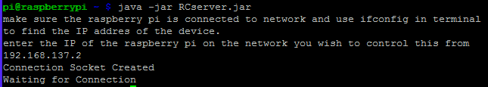 19-8-14: before I did anything else I set up my wifi adapter, first I followed the instructions [here](http://askubuntu.com/a/170576) to make sure I had the latest drivers. Then I plugged in the wifi adapter and a monitor and connected to my wifi. I could then disconnect from the monitor and instead used SSH.

When I first ran the program I Had error because I did not run as sudo.

Also there was 2s lag, this is explained in the RCserver doc.

29-8-14: the raspberry pi suddenly stoped working. It would reboot continuasly and there appered to be an error about the USB on the monitor. So I re installed the OS but then it did not boot at all so I ordered a new on.

On my new PI after enabling SSH in raspi-config I ran “sudo apt-get update” this updates the repositorys then “sudo apt-get upgrade –y” this updates all the packages and the –y means that it automatics says yes to download them. I then used “sudo rpi-update” to update the linux/debian version on the pi. I then set up wifi using the same method as before. I then tested that the application worked fine (downloading and lantching it using the same method as before).